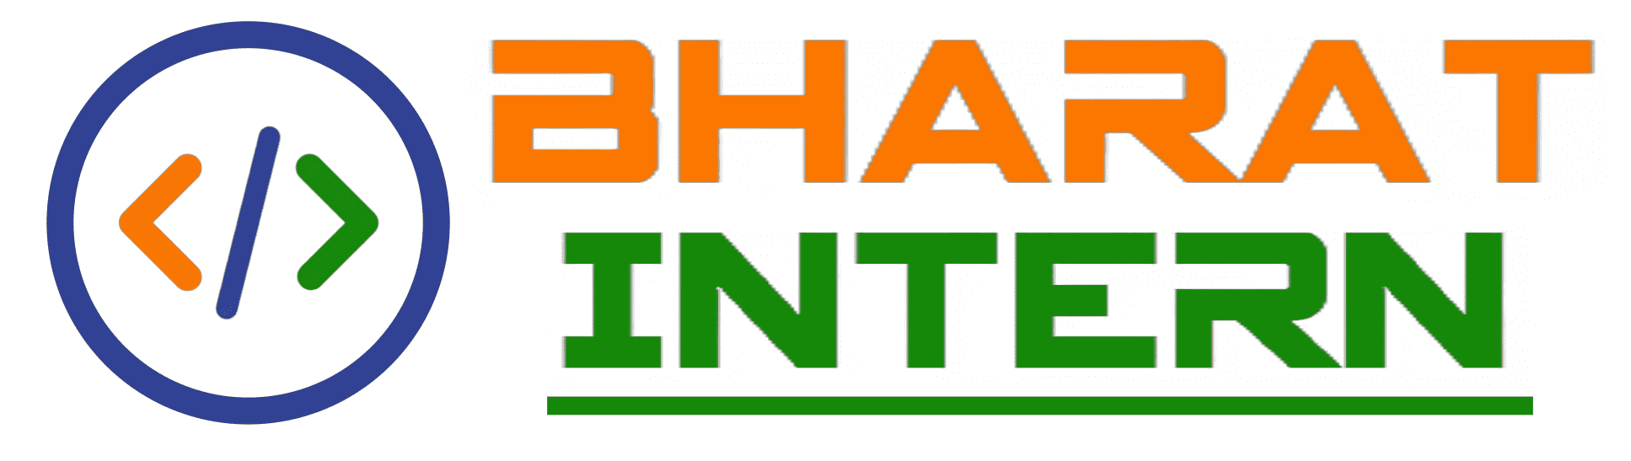

Unlock your Potential

with

“bharat intern”

NAME-SOMYA SHISHODIA

PHONE NO.-7678284982

EMAIL ID.-SHISHODIASOMYA31@GMAIL.COM

Question1 Resume Parser:

Create an AI to find the correct canditdate for the job by using NLTK and some words. Use only Jupyter notebook code.

import nltk

from nltk.corpus import stopwords

# Download the stopwords corpus if not already downloaded

nltk.download('stopwords')

def parse_resume(resume_text, job_keywords):

    # Tokenize the resume text into individual words

    resume_tokens = nltk.word_tokenize(resume_text.lower())

    # Remove stopwords from the resume tokens

    stop_words = set(stopwords.words('english'))

    filtered_tokens = [token for token in resume_tokens if token.isalpha() and token not in stop_words]

    # Count the number of occurrences of each keyword in the resume

    keyword_counts = {keyword: filtered_tokens.count(keyword) for keyword in job_keywords}

    # Find the candidate with the highest keyword count

    best_candidate = max(keyword_counts, key=keyword_counts.get)

    return best_candidate

# Example usage

resume = '''

John Doe

Software Engineer

Skills:

- Python

- Java

- Machine Learning

- Web Development

Experience:

- Software Engineer at XYZ Inc.

Education:

- Bachelor's Degree in Computer Science

'''

job_keywords = ['python', 'machine learning', 'web development']

best_candidate = parse_resume(resume, job_keywords)

print("Best candidate:", best_candidate)

**Question2 Auto Correct Tool :**

In this task the AI must correct the word or give the word which is nearest to it.Use only Jupyter notebook code.

import difflib

# Dictionary of known words

dictionary = ["apple", "banana", "cherry", "orange", "pear","right"]

# Function to perform auto-correction

def autocorrect(word):

    corrected_word = difflib.get_close_matches(word, dictionary, n=1)

    if corrected_word:

        return corrected_word[0]

    else:

        return None

# Example usage

input_word = ""

corrected_word = autocorrect(input_word)

if corrected_word:

    print(f"Input: {input_word}")

    print(f"Auto-corrected: {corrected_word}")

else:

    print("No auto-correction available.")

**Question 3 Translator App**:

You have to create a translator AI which translate between any two languages. Its upon you to choose language.

#-----------Task-3----------

#-------TRANSLATOR APP------

from tkinter import *

from tkinter import ttk

from googletrans import Translator,LANGUAGES

root =Tk()

root.geometry('1100x320')

root.resizable(0,0)

root['bg']='skyblue'

root.title('Language translator by Shreya Singh')

Label(root,text="Language Translator" ,font = "Arial 20 bold",border='2',relief="solid").pack()

Label(root,text="Enter Text" ,font ='arial 13 bold' ,bg='white smoke',border='1',relief="solid").place(x=165, y=90)

Input_text=Entry(root,width=60)

Input_text.place(x=30,y=130)

Input_text.get()

Label(root,text="output" ,font ='arial 13 bold', bg='white smoke',border='1',relief="solid").place(x=780,y=90)

Output_text=Text(root,font='arial 10',height=5,wrap=WORD,padx=5,pady=5,width=50)

Output_text.place(x=600,y=130)

language= list(LANGUAGES.values())

dest_lang= ttk.Combobox(root,values=language,width=22)

dest_lang.place(x=130,y=180)

dest_lang.set('choose language')

def Translate():

    translator= Translator()

    translated= translator.translate(text=Input_text.get(), dest= dest_lang.get())

    Output_text.delete(1.0, END)

    Output_text.insert(END, translated.text)

trans_btn=Button(root,text='Translate',font='arial 12 bold', pady=5, command=Translate,bg='orange',activebackground='green')

trans_btn.place(x=445,y=180)

root.mainloop()